# Homework #2: Mastering the Basics of SQL Server

|  |
| --- |
| * This is an individual assignment, and is worth 20 points. * The due date is Monday, February 1st Midnight (*late work not accepted*) * You have to use the “Homework #2-Tasks.docx” file to provide your answers. Change this file name according the naming convention below. * Use the following naming convention: homework, underscore, last name, first initial, and extension (e.g., Homework #2_ImG.docx). If you do not follow the convention, I will deduct 1.0. * Do not copy any of the sample screenshots provided as illustrations. * Report any issues before the deadline. |

(**Task 1: 5 points**) Complete Task #2 through Task #4 while placing your sql files in Queries. Show in a screenshot that your Homework 2 project in Solution Explorer contains **three** sql files in **Solution Explorer**.

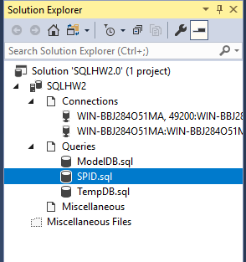

**(Task 2: 5 points**) Show in a screenshot that **DatabaseLog_test** table is created in **MySecondDatabase**, and **not** in **MyFirstDatabase**.

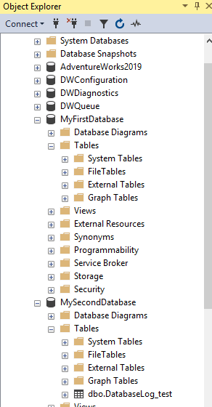

(**Task 3: 4 points**) Create the three temp tables listed above and show their existence using the SELECT command above. Attach a screenshot.

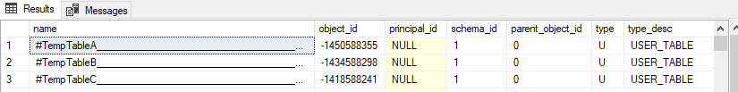

(**Question: 1 points**) When do we use temporary Tables? List three scenarios. When do we use table variable over temp table? For the answers, go to the link above.

1. “When we are dealing with large number of row manipulation stored procedure”
2. “We have complex join operations”
3. “It is useful to replace the cursor. We can store the result set data into a temp table and manipulate it from there”

Using table variable over a temp table when there is not a lot of data. When data is larger we using temp table as the are more reliable to use.

(**Task 4: 5 points**) Fill in **all** the blanks. Keep in mind that you have made a connection via a dynamic port not the default number. Your answers to the second column must be consistent with the connection you made.

|  |  |  |
| --- | --- | --- |
|  | **Name/Number** | **Description (definition)** |
| SPID | 137 | Server process ID or session ID defines the scope and memory space and can’t be interacted with other SPID’s |
| SID | 0x01050000000000051500000002121124907FD69BA9D25C71E803…. | Security ID identifies the security context of the login and is uniquely within the server instances |
| principal_id | 259 | Identifies the login as a securable within the servers. |
| net_library | TCP/IP | Allows communications using different network protocols |
| local_tcp_port | 49200 | Current Local TCP port that is being used. |

In addition, show the result of each of the four queries in a screenshot.

SPID:

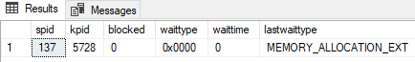

SID



Principal ID:



NET Library



Local TCP Port

